
Deals in All Kinds of New & Used Desktop & Laptops
Sales & Service

Ref.NO TCOM/JAN-26 Date: 13-01-2026

MS: MIKHRAQ AHMAD KHAN.
Address: PWD ISB,

S N | Description | Qty | Unit price | Total  Amount
1  2 | LOGITECH H390 OGR  5 MONTH WARANTY  DELL SOUNDBAR ORG | 10  03 | 9200  2000 | 92,000/.  6000/.
TOTAL AMOUNT |  |  |  | 98000/.


TERMS & CONDITIONS: -
PAYMENT MODE: CASH
ONE WEEK CHECK WARRENTY

Thank you and best regards,

THIS IS A SYSTEM GENERATED INVOICE AND DOES NOT NEED ANY SIGNATURE

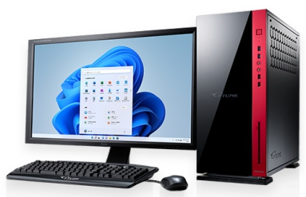
Branch 1: Anwar Chowk, Wah Cantt. 0345-5982628 051-4265300
Branch 2: Bilal Market NawabAbad, Near Barrier 2 WahCantt. 0301-5177866 tcomwah@gmail.com

